Project Planning Phase
Project Planning Template (Product Backlog, Sprint Planning, Stories, Story points)

Date | 04 October 2026
Team ID | SWTID-2026-6519
Project Name | Script-Controlled ACL – Restrict Record Access Based on Field Value
Maximum Marks | 5 Marks

Product Backlog, Sprint Schedule, and Estimation (4 Marks)
Use the below template to create product backlog and sprint schedule
Sprint | Functional Requirement (Epic) | User Story Number | User Story / Task | Story Points | Priority | Team Members
Sprint-1 | User & Role Management | USN-1 | As an administrator, I can create a test user (EEE User) so that I can test branch-based access. | 1 | High | Suhas V
Sprint-1 |  | USN-2 | As an administrator, I can create the custom roles bb1, bb2, bb3 and bb4. | 2 | High | Sureshbabu M
Sprint-1 |  | USN-3 | As an administrator, I can assign all four roles to the EEE User. | 1 | High | Vignesh Kumar S
Sprint-1 | Data Model | USN-4 | As an administrator, I can create the custom table Institution Details (u_institution_details). | 2 | High | Anuja P
Sprint-1 |  | USN-5 | As an administrator, I can add the fields Student Roll Number, Student Name, Faculty Name, Branch, Email, Phone Number and Description. | 3 | High | Archana S
Sprint-1 |  | USN-6 | As an administrator, I can insert sample records for ECE, EEE and CSE branches. | 2 | Medium | Suhas V
Sprint-2 | Read ACL | USN-7 | As an administrator, I can elevate to security_admin and create a Read ACL (record, read, advanced) on u_institution_details that requires role bb1. | 3 | High | Sureshbabu M
Sprint-2 |  | USN-8 | As an administrator, I can add the data condition Branch is EEE to the Read ACL. | 2 | High | Vignesh Kumar S
Sprint-2 |  | USN-9 | As an administrator, I can add an advanced script that returns true for admin / bb1 and false for everyone else. | 5 | High | Anuja P
Sprint-2 |  | USN-10 | As a user with role bb1, I can open the Institution Details list and see only EEE-branch records. | 3 | High | Archana S
Sprint-3 | Create & Write ACL | USN-11 | As an administrator, I can create a Create ACL that requires role bb2. | 3 | High | Suhas V
Sprint-3 |  | USN-12 | As a user with bb1 and bb2, I can see the New button and create records. | 2 | High | Sureshbabu M
Sprint-3 |  | USN-13 | As an administrator, I can create a Write ACL that requires role bb3. | 3 | High | Vignesh Kumar S
Sprint-3 |  | USN-14 | As a user with bb1, bb2 and bb3, I can edit the Description of EEE records inline. | 2 | Medium | Anuja P
Sprint-4 | Delete ACL & Validation | USN-15 | As an administrator, I can create a Delete ACL that requires role bb4. | 3 | High | Archana S
Sprint-4 |  | USN-16 | As a user with all four roles, I can delete an EEE record. | 2 | High | Suhas V
Sprint-4 |  | USN-17 | As a user without the roles, I must not see any record in the list. | 2 | High | Sureshbabu M
Sprint-4 |  | USN-18 | As an administrator, I can still see the records of all branches. | 2 | High | Vignesh Kumar S
Sprint-4 |  | USN-19 | As an administrator, I can document the work as a project report. | 3 | Medium | Anuja P

Project Tracker, Velocity & Burndown Chart: (4 Marks)
Sprint | Total Story Points | Duration | Sprint Start Date | Sprint End Date (Planned) | Story Points Completed (as on Planned End Date) | Sprint Release Date (Actual)
Sprint-1 | 11 | 6 Days | 07 Sep 2026 | 12 Sep 2026 | 11 | 12 Sep 2026
Sprint-2 | 13 | 6 Days | 14 Sep 2026 | 19 Sep 2026 | 13 | 19 Sep 2026
Sprint-3 | 10 | 6 Days | 21 Sep 2026 | 26 Sep 2026 | 10 | 26 Sep 2026
Sprint-4 | 12 | 6 Days | 28 Sep 2026 | 03 Oct 2026 | 12 | 03 Oct 2026

Velocity:
Imagine we have a 10-day sprint duration, and the velocity of the team is 20 (points per sprint). Let’s calculate the team’s average velocity (AV) per iteration unit (story points per day)

Our team's velocity = total story points / number of sprints = 46 / 4 = 11.5 story points per sprint. Average velocity per day (6-day sprint) = 11.5 / 6 ≈ 1.92 story points per day.

Burndown Chart:
A burn down chart is a graphical representation of work left to do versus time. It is often used in agile software development methodologies such as Scrum. However, burn down charts can be applied to any project containing measurable progress over time.
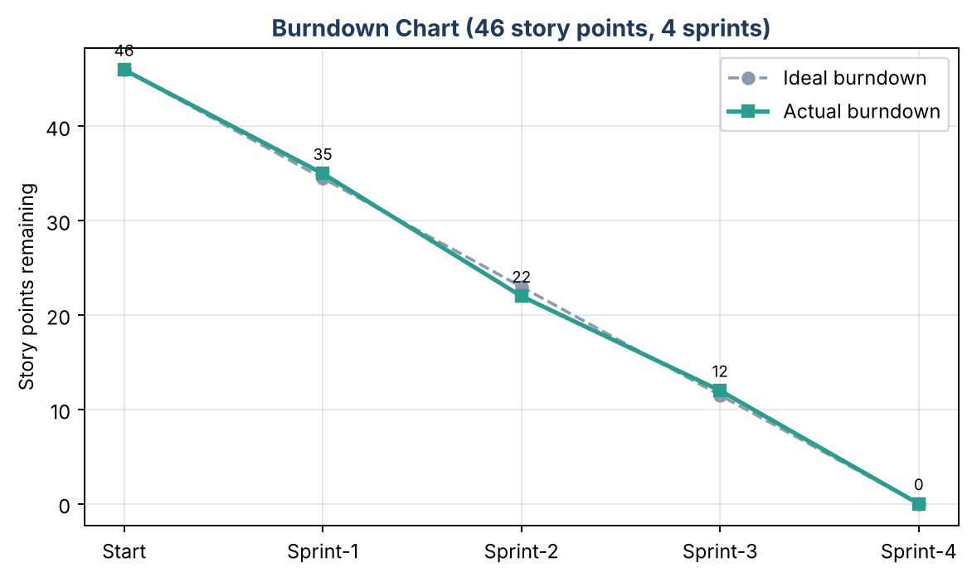

https://www.visual-paradigm.com/scrum/scrum-burndown-chart/
https://www.atlassian.com/agile/tutorials/burndown-charts

Reference:
https://www.atlassian.com/agile/project-management
https://www.atlassian.com/agile/tutorials/how-to-do-scrum-with-jira-software
https://www.atlassian.com/agile/tutorials/epics
https://www.atlassian.com/agile/tutorials/sprints
https://www.atlassian.com/agile/project-management/estimation
https://www.atlassian.com/agile/tutorials/burndown-charts

